REPORT ON MATERNITY BENEFIT ACT GUEST LECTURE 2022

NAME OF THE PROGRAMME: | “MATERNITY BENEFIT ACT”  Guest lecture for final year students of LLB IVth SEM (3 Years course) and VIIIth SEM(5 Years course)
DATE AND DAY: | 19th April 2022
TIME: | 11.45 A.M TO 12.45P.M
GOOGLE MEET LINK:
PROGRAMME CO-ORDINATOR: | Asst.Prof. Sarika kamdi,
RESOURCE PERSON : Adv. Chetan Dhore

On 19th April 2022 an Online guest lecture was conducted by Dr. Ambedkar College, Department of Law, Deekshabhoomi, Nagpur for the final year students of LLB VIIIth Sem(5 yrs) and IVth Semester (3 years course). Total 50 students attended the program. The Program was conducted under the guidance of Prof. Dr. H.V.Menon, Head of the Department of Law, Room No. 11 at 11.45 A.M.
About the speaker

Advocate Chetan Dhore is a law graduate from Dr Ambedkar College Deekshabhoomi Nagpur and with Gold medal in constitutional law in his masters (LLM) from Rashtra Sant Tukadoji Maharaj Nagpur University.
Practicing as an Advocate in High Court of Bombay since 2010 and in different courts all over the India including different tribunals and the Supreme Court of India. Specialisation are drafting and pleading civil litigations, Public Interest Litigation, Writ petition under article 32 of the constitution.
He is imparting training to group A gazetted officers recruited under the Indian Ordnance Factories Act. Special command on arbitration and conciliation. He has been a mentor and guide for many judicial officers who are presently working as JMFC and District Judges.

The course content delivered in the lecture is as follows
“MATERNITY BENEFIT ACT’’
The speaker of the session Adv. Chetan Dhore presented the keynote address on ‘MATERNITY BENEFIT ACT’ and its importance in labour law studies with best suitable decided case laws which were essential for the understanding of the subject. He explained the various provisions of maternity benefit act.
He discussed on the different aspect as to how to read and decipher labour laws in general and eventually explained the provisions of maternity benefit act and objectives behind framing this particular act. He also discussed the constitutional perspective of maternity benefit act and its importance. He explained how where the act is applicable. He highlighted the duties of the employees who avail the benefit of this act and Key highlights of amendment
At the end of the session, he inspired the students by live interaction and answered all the query related to the act.

Adv. Chetan Dhore Interacting with students
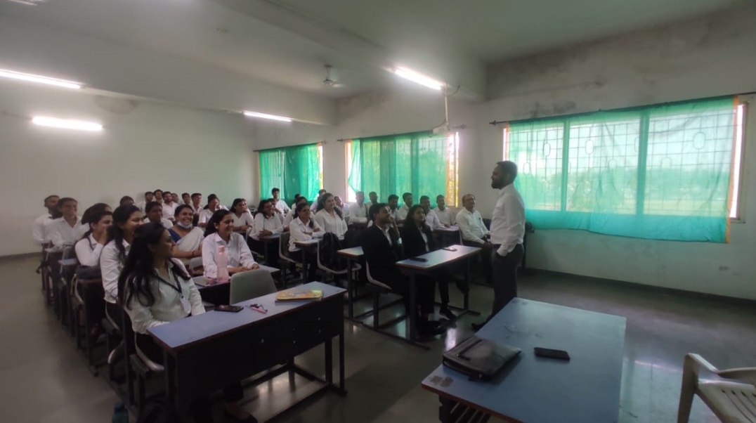

feedback responses obtained from through google form the participants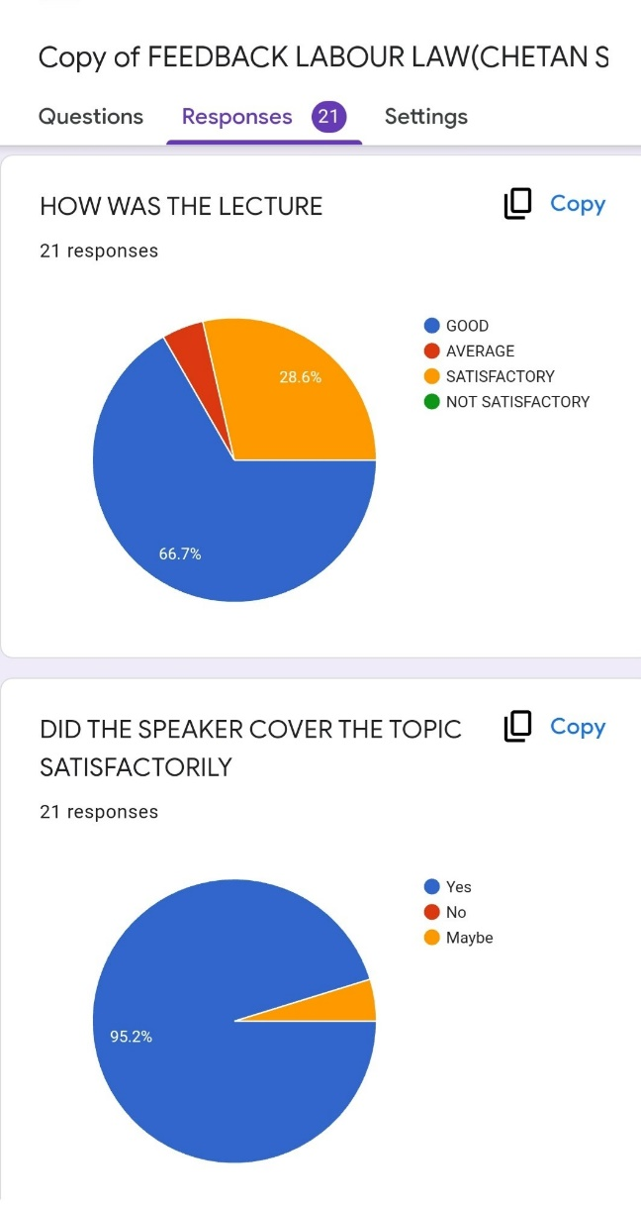

The objectives of the webinar were achieved. The overall session discussion benefitted the faculties and the students. This online lecture would help the participants in their academic studies and also in their future professional career.

